SUBA STARS FOOTBALL CLUB P.O BOX 148-40308, Sindo, Homa Bay  [subastarsfc@gmail.com](mailto:subastarsfc@gmail.com)

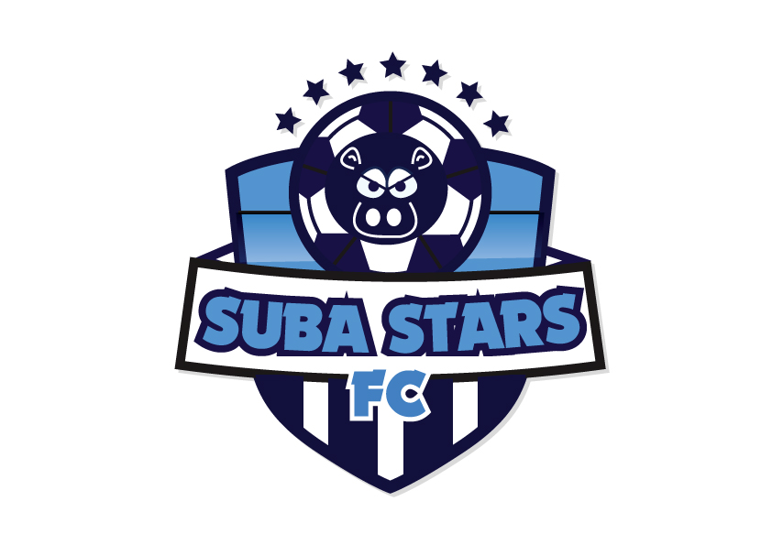 PROPOSAL FOR SPONSORSHIP AND FUNDING

2020/2021

I will take this opportunity to give you a brief history of the Club, our current programs and future ambitions

**ABOUT US**

Suba Stars was established in 2019 and marked our 1st anniversary in 2020 Suba stars is registered under Ministry of Tourism, Culture and Sports under registration No HBC/TC$S/008/406

The home Ground of the club is Sindo Town, Nyakiamo Stadium, Central Division; Suba South constituency-Homabay County. The operational jurisdiction of Suba Stars covers; Suba South constituency, Suba North and Mbita constituency.

The club has approximately 30 players, comprising of Senior Men and Junior boys and also working out on women and girls football teams.

We are affiliated with the Kenya Football Federation (FKF), and participated in 2019/2020 Division 2 of Football Kenya Federation (Nyanza North Branch) competition and finished the league at position 5. The league ended prematurely in first leg due to Covid-19 pandemic.

**OUR VISION**

Suba Stars Club believes that youth is a time of promise, it is our Vision;

* to provide opportunities for young lads who aspire to play and learn the fundamentals of soccer, life skills and peer Education

**OUR VALUES**

What generates the phenomenal energy behind Suba Stars Club is the founder’s desire to empower the youth such that they become productive participants in Kenyans long -term economic and social development. We see Suba Stars evolving into an institution in the forefront of dynamic social development program providing critical interventions and social support systems and are determined to achieve this by giving the young boys and girls the chance to survive and acquire the essential tools of life: an opportunity to succeed.

We believe that the fundamental needs of a productive young person are nutrition, health, education, skills and self -confidence: and endeavor to empower them through sport -based program that combines the complementary disciplines of sports and academic study and mentorship; to mold young men and women of character-future leaders

**OUR MISSION;**

Our mission is to develop and manage an institution that is a home place of learning excellence of the youth of Kenya, by providing emotional, intellectual, vocational, and physical development to young boys and girls in Kenya such that they achieve their dreams of becoming successful soccer players, coaches and administrators.

**MOTTO:**

To **dare** is to **do**

**INTRODUCTION:**

Soccer is viewed by many as a major sporting event in the world. The game of football has resulted to skill development in many nations across the globe and has contributed in enriching individuals. Besides, sport in general and football in particular have emerged as a single unifying factor, even in the moment of political, ethnic and socio-religious tension and feuds. Nations across the world have united behind this game. Football has bridged racial and tribal divide and brought people of other nations into union of oneness.

Most youths are ready to defy some of the challenges prevailing in the world today such as unemployment and economic hardship, which has reduced them to the level of desperation. Most of them have given up hopes and have buried their talents and indulge in activities such as drug abuse, prostitution, gangsterism and crime. It can therefore not be argued that idleness breeds crime and other numerous malpractices that can only lead to the destruction of individuals and their communities.

In a Kenyan context, there are numerous challenges still predominant in most of its constituencies and counties such as Suba South, Homabay county. This is because the desire and zeal to conquer and be number one has unfortunately not been matched with opportunities and facilities to nurture their skills and talents. It is in this context that Suba stars football club is pursuing its passion to transform the lives of the budding Kenyans talents

The team also intends to provide mentorship platform to the youths to help them gain social life skills and economic empowerment skills through constant engagement that will reduce the ever-rising incidences of; Drug Abuse, HIV AIDS Prevalence rate, Sexual Gender Based Violence cases(SGBVS), Sanitation issues, Environment challenges and high Crime rates within the fisher folk community.

Suba Stars opens its doors and arms for partnerships with local and international profit organizations, Government bodies and NGOS. The partnerships will be in form of community mobilization for policy and projects incorporations in the community, advocacy and campaigns on social issues, advertisements and selling of their products through our large fan base and acting as peace Ambassadors to build a united community of Kaksingri and the entire World

**CLUB PROGRAMS**

Suba Stars Youth Program (U-17yrs, Under 13)

This program is designed for highly talented and committed players and is focused on guiding young players towards team play through co-operatives small sided games (3v3 and 4v4) and matches. Players are coached to make effective choices about attacking and defensing as a small sided team. Players are taught to understand the different positions within a team and can select and demonstrate specific attacking and defending skills. Heading will also be introduced at this stage. Games involving these players will take more shape in attack and defense, and knowledge of concepts and tactics will improve. The initial stages of developing physical attributes such as speed, strength and endurance will also be incorporated to this program.

**Objectives**

To produce players to play at the highest professional level by creating a proper educational program entailing:

* Training access 4/5 times a week
* Regulated academic environment-ensuring a child is first a student then a player, but also ensuring the child is given time and freedom to train
* Regulated social environment to protect the child from damaging influences such as drugs, violence and crime.
* Character Building and development of human virtues

**Football Kenya Federation Div 2 League (FKF Over 18)**

Suba Stars club participates in a number of opportunities for players above 18 yrs. to engage in recreational and competitive soccer. It is our desire to develop kids who not only possess good skills as soccer players, but strong character through sportsmanship and community spirit. Football Kenya Federation Soccer league season typically run in (Nov-May).

**GOAL AND RATIONALE**

The future of every country and its related society lies in the youthful population. Investing in youths’ entails building a solid foundation for future leaders by maximizing their potentials. Suba Stars has come to realize that in partnership with the Government as well as other stakeholders, young people can be given a chance of making it in life through sports. The founders and promoters of Suba stars equally believe that young people are rough diamonds whom if well-polished shall shine for the whole humanity.

The goal of the project is to offer an opportunity for development of talent in youth through training and nurturing of their talents in football, in the junior, youth and senior categories. Most of the players are usually identified through county, constituency competitions and street kid playing areas. Moreover, the object seeks to establish an exchange visit program between the team and advanced teams and sport academies.

The talents in football, futsal and street soccer in Suba Stars abound. This proposal seeks to build youth capacity in these domain through partnership with football clubs, training institutions, and centres.We therefore believes that it is an urgent to build a soccer academy that shall provide the training grounds for young men and women that shall also serve as a nursery for our national teams.

**OVERALL OBJECTIVES**

In a region that does not count many industries and resources that constitute a source of empowerment through gainful employment, the overall objectives of this proposal resonate with Suba Stars Club and include:

* Creating a community and sustainable academy in order to develop football, futsal, street soccer, sports education for coaches and administration in this part of Suba, Kenya
* Identifying sports talents in young people and giving them a chance at making career even away from our academy.
* Engaging young people in physical and moral education (life skills and peer education) with a view to reducing crime rate, drug abuse as well as the fight against HIV/AIDS
* Training young people in the sustainable management of health, bio-diversities and environmental protection
* Building friendship ties with stakeholders as well as other sports-oriented entities the world over and participating in international tournaments, exchange programs, work camps and activities that promotes friendship, tolerance and fight against racism and all forms of discrimination

**EXPECTED OUTCOME**

The importance of this project lies also in the anticipated outcome and the benefits would be multi-dimensional

**Youth Beneficiary**

* Junior and senior footballers are trained and equipped with basic material for retraining and career development.
* With sponsorship, outstanding football players who need immediate and sustained attention vital for possible professional care would receive adequate training from the academy.
* The training shall equally reveal more hidden talents in young people not only from Suba South constituency around Homa bay county but equally from other parts of our country, Kenya.
* The training activities shall equally present and encourage the spirit of competition and especially self-challenge in all participants, whose spirit shall build strong personalities in each one of them.
* The coming together of young people from all parts of the country shall foster friendship ties and encourage national integration that is indispensable in national unity and national building

The Academy

* The academy will succeed in giving a chance of self-esteem and discovery to young people, which is a resumé of our objectives.
* The Academy expects to cause young people to realize that sports can give them a future and above all that sports keep them out of various malpractices.
* The academy expects to instill a sense of responsibility and partnership in the participants, which shall then have an overall effect on their day to day activities. By the end of training activities, the participants would emerge as people who respect the notion of “Common Good “which is a prerequisite for future nation builders
* The Academy by the training of young people will exhibit the principles of self-reliant development and contribute its own quota to national development.
* The Academy programs are geared towards physical, moral, linguistic and professional development of the youth in local, national and international

Football

The Community

* The envisaged training activities shall reinforce the spirit of friendship and unity amongst young people who constitute a very active and consequently very volatile section of the population.
* The training activities shall be welcome by the local authorities as an antidote against the growing rate of crime, irresponsible sexual behaviors and drug abuse.
* We finally expect that the nation shall discover some of the rough diamonds, which need polishing in the young participants so that Kenya should be proud of new stars that may defend its colours at world stage including World Cup
* Even if none of the above occurs, we would have succeeded in the physical and moral education of our young people and given them enough reason to dream, which dreams they may realize some day with or without us. This is what we call success.

Sponsors’ Benefits

* Increase sponsors profile by marketing its products and services to members of the academy and the community through press release, internet and newsletter.
* Ensure our sponsors are well marketed by our players, and all the people that attend our matches by promoting their products and services whenever possible.
* Increase Branding with local market.
* Generate awareness and goodwill within the defined target audience.
* Provide a cost effective and efficient alternative to mainstream advertising.
* Assist the club to ensure sports remains affordable to all players.

**PROJECT SUSTAINABILITY**

This project meant for training of young people, shall be a continuous process of identifying, training, building capacities and causing sports men and women to participate in national and international events.

Suba Stars also plans to host local and international youth tournaments, put sports facilities, a training Centre, coaching courses and seminars, sports related education, sports equipment and apparel shop, event branding and marketing and a sports resource center which are income generating

Suba stars shall provide a sustainable way of transforming sports in Kenya, a country blessed with potential stars just waiting to shine.

**MONITORING AND EVALUATION**

The following assumptions were made in presenting this Suba Stars Academy proposal, these includes;

1. That the Academy will identify and train those youth who are talented in football.
2. That the Academy will help to expose the trained footballers into the national and international markets.
3. That the academy will train football coaches, and administrators.
4. That the academy will create jobs in many directions.
5. That the Academy will be a developing project by building football and other infrastructure.
6. That both the public and private sector will welcome the Suba Stars initiative and support it
7. That assistance and funding will be made available for the resource of the academy by whoever Suba Stars approaches.
8. That the academy will market the product of its sponsors and funding agents.

**PARENTAL /GUARDIAN CONSENT:**

The children are all on the program with parental consent

**CLUB LEADERSHIP**

The club is run by the following committee of appointed Officials and the Club Founders

|  |  |  |  |
| --- | --- | --- | --- |
|  | **Position** | **Qualification** | **Responsibility** |
| 1 |  |  |  |
| 3 |  |  |  |
| 4 |  |  |  |
| 5 |  |  |  |
| 6 |  |  |  |
| 7 |  |  |  |

Chairman

Secretary

Treasurer

Team manager

Liaison Officer

Club CEO

CLUB CORPORATE SOCIAL RESPONSIBILITY

This is an initiative undertaken by the club to improve social economic status of its members and community at large.” Suba Stars Greening Initiative” is a multifaceted initiative that includes but not limited to;

* Tree planting/Farm Forestry (Agro Forestry)
* Environmental clean -up exercises
* Use and advocating for use of renewable energy.

Our CSR program has been focused on 2 pillars namely, Environment and Education. We are driven to improve livelihoods in our communities through embarking on positive environmentally sustainable initiatives.

Through our education pillar we lean towards positively influencing the children and youth in Kenya and tapping their talents to unleash their individual potential for the good of their community, Suba and ultimately developing Kenya

|  |  |  |  |
| --- | --- | --- | --- |
| **SUBA STARS ACADEMY 2020/2021** | | | |
| **ITEM** | **NO/QTY** | **UNIT COST(Kshs)** | **TOTAL(Kshs)** |
| Office Rent | 12 months | 5,000.00 | 60,000.00 |
| Pitch Hire | 12 months | 5,000.00 | 60,000.00 |
| Coaching Staff Allowances | 6x12 | 10,000.00 | 720,000 |
| Utility Bills | 12 Months | 5,000.00 | 60,000.00 |
| Referee Fees | 24 matches | 5,000.00 | 120,000.00 |
| Communication/Internet | 12 Months | 10,000.00 | 120,000 |
| Printing/Publicity | 1 per Year | 30,000.00 | 30,000.00 |
| FKF League Affiliation fee/Competitions | 1 per Year | 45,000.00 | 45,000.00 |
| Transport | 12 away matches | 35,000.00 | 420,000.00 |
| Refreshments | 72 sessions | 1,500.00 | 108,000.00 |
| **TOTAL EXPENDITURE** | | | **1,743,000** |
|  | | | |
| **TRAINING EQUIPMENT COST** | | | |
|  | | | |
| **TRAINING EQUIPMENT COST** | | | |
| **ITEM** | **NO/QTY** | **UNIT COST(Kshs)** | **TOTAL(Kshs)** |
| Soccer Balls | 50 pieces | 2,500.00 | 125,000.00 |
| Training Cones | 48 pieces | 450.00 | 21,600.00 |
| Space Markers | 4 sets | 4,500.00 | 18,000.00 |
| Portal/Flexi goals | 3 pairs | 18,000.00 | 54,000.00 |
| Goal Nets | 5 pairs | 5,500.00 | 27,000.00 |
| Training Bibs | 48 pieces | 400,00 | 19,200.00 |
| Pump | 2 pieces | 1,800.00 | 3,600.00 |
| Playing Kit(local) | 80 pieces | 2,500.00 | 200,000.00 |
| Soccer Boots | 40 pieces | 3,500.00 | 140,000.00 |
| Goalkeeper Gloves | 10 pairs | 1,500.00 | 15,000.00 |
| Coaching Boards | 4 pairs | 3,500.00 | 14,000.00 |
| Coaches Training Kit | 10 sets | 4,500.00 | 45,000.00 |
| Corner Flags Posts with Spring | 4 pieces | 4,600.00 | 18,400.00 |
| Mini bus | 1 | 1,500,000 | 1,500,000 |
| **TOTAL EXPENDITURE** | | | **2,200,600** |
| **GRAND TOTAL** | | | **3,943,600** |

SUBA STARS GALLARY

Suba Stars posting before a league match

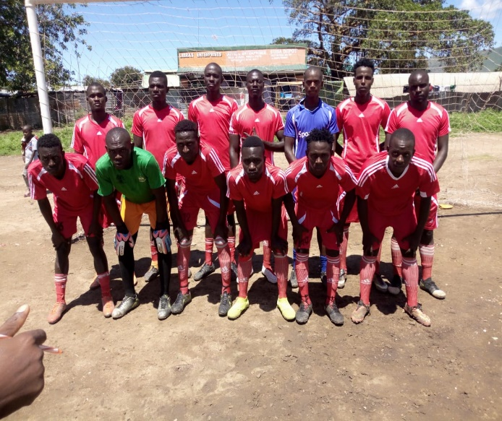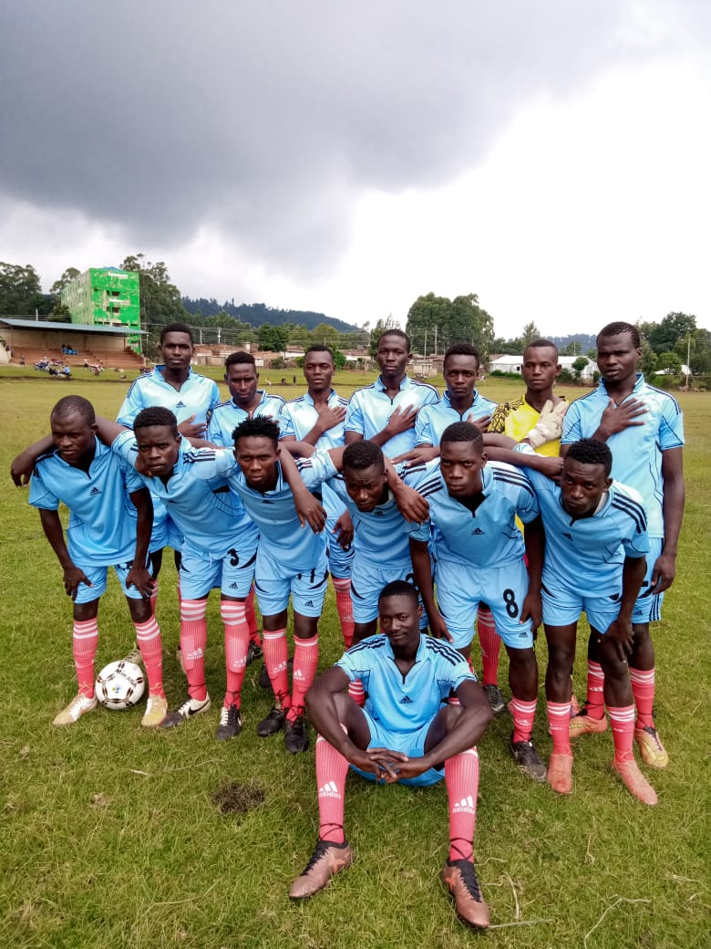

Suba Stars under 13 players posting for a photo

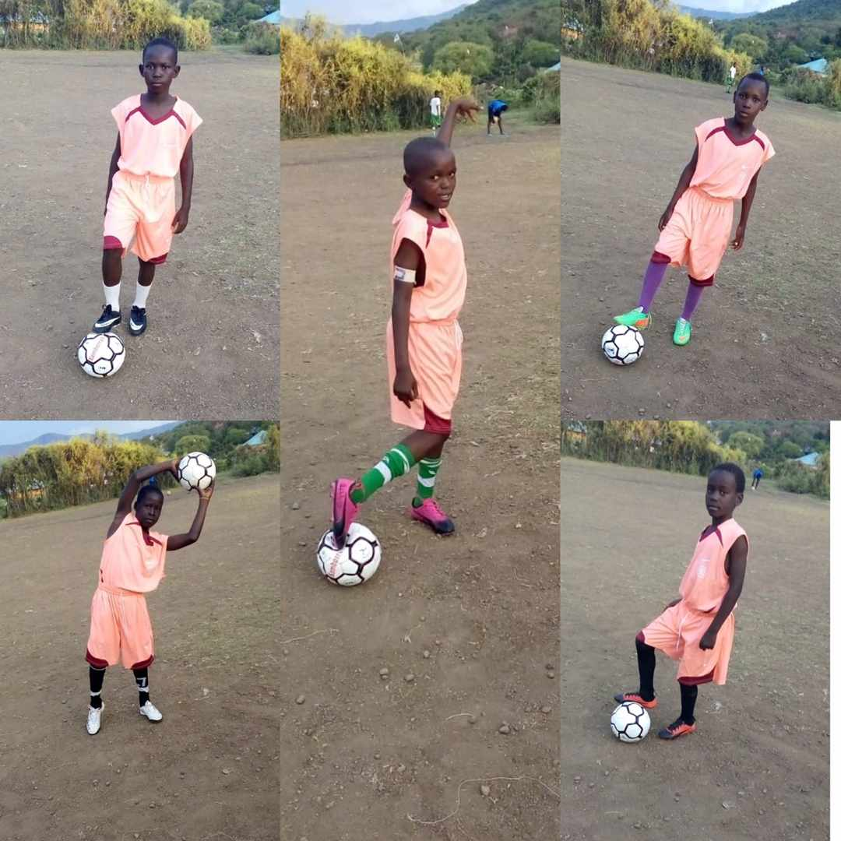

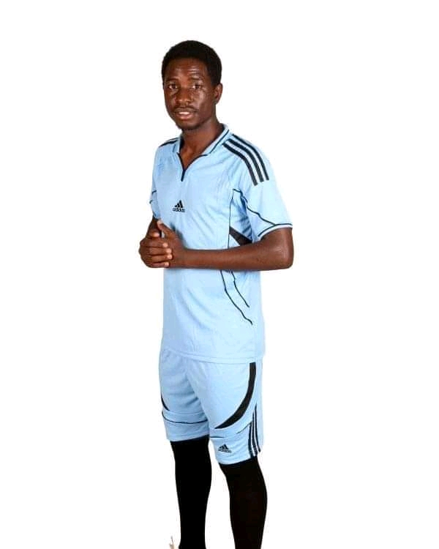

Suba Stars Bank Account Details

Pay Bill NO.790645

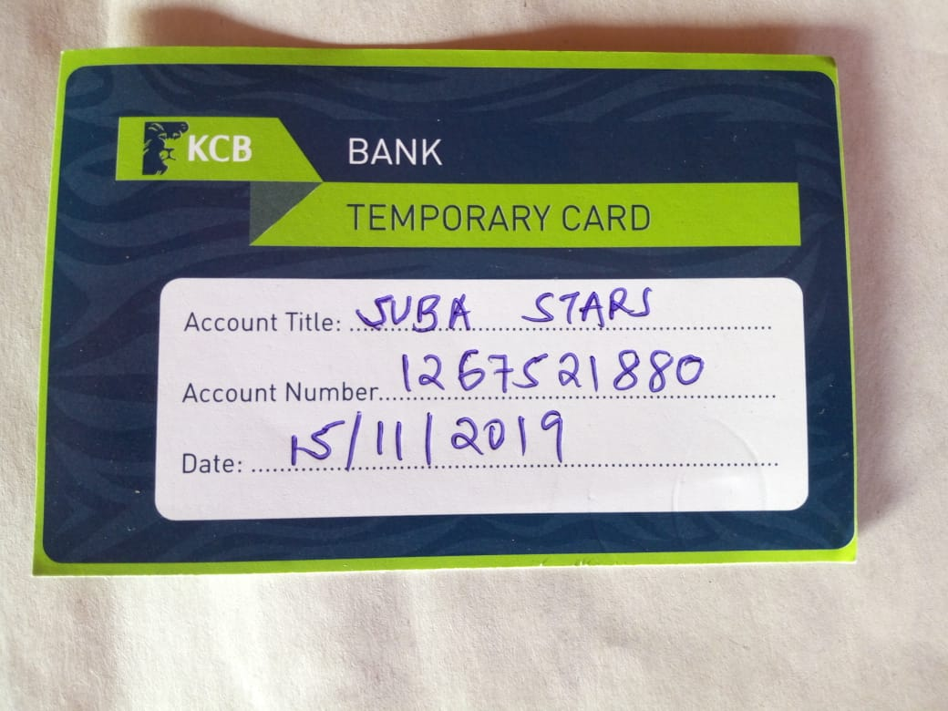

Suba Stars Certificate

